Virtual Reading Room, University of Reading, Special Collections

Step 1 Register for the Virtual Reading Room
Step2 Click on browse collections

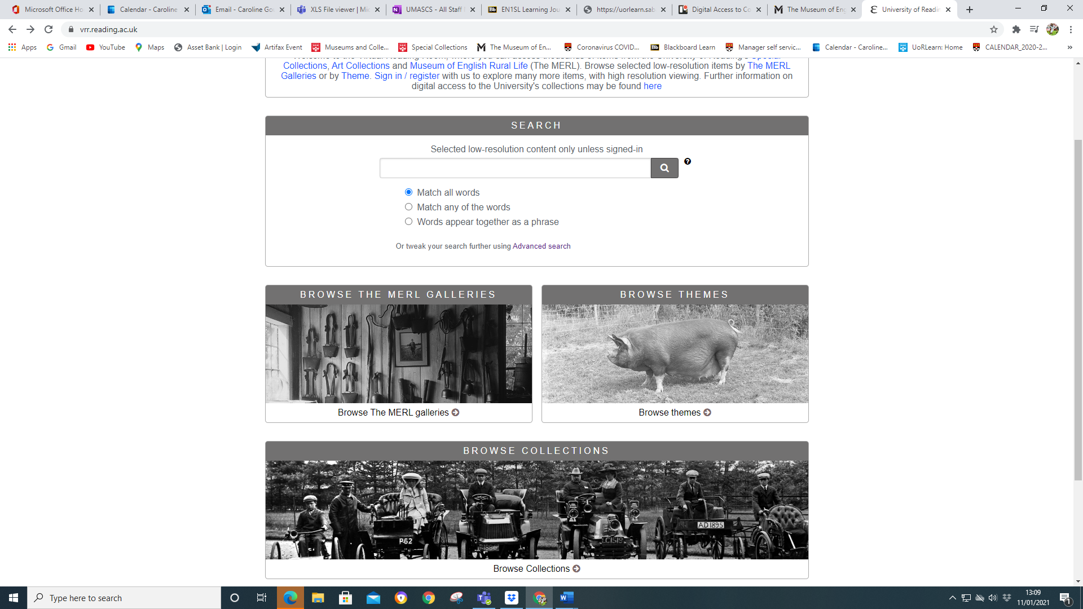

Step 3 Click on MERL collections
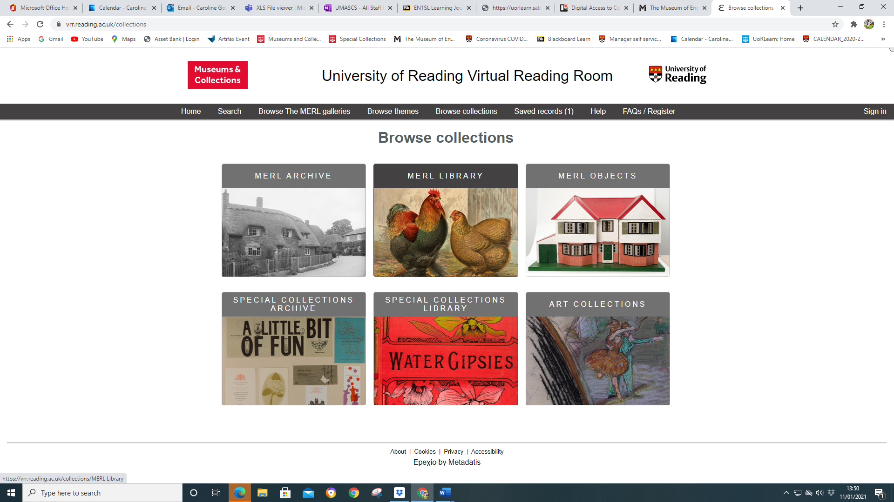
Step 4 Click on Architect records

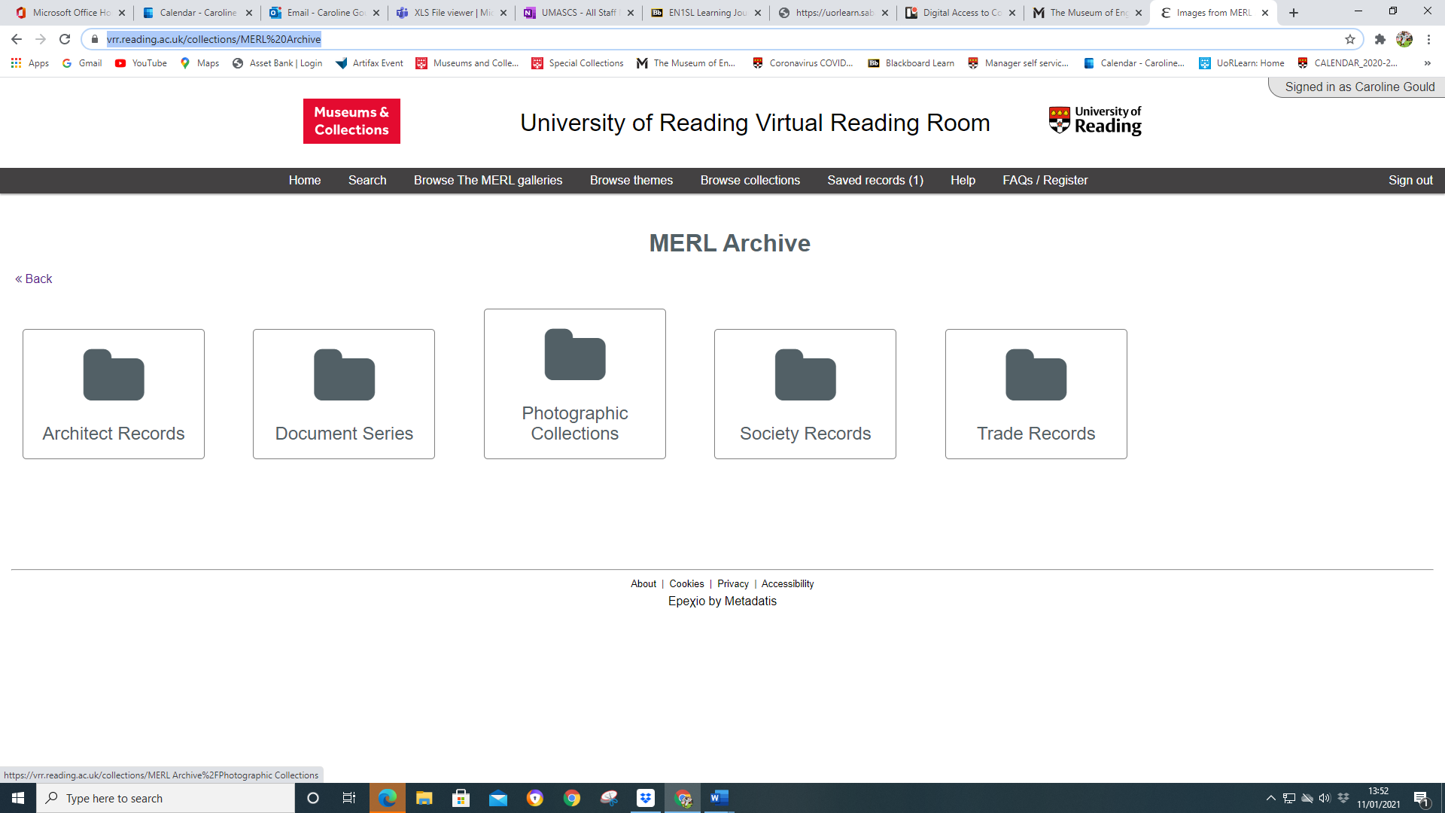

Step 5 Click on Peter Shepheard

